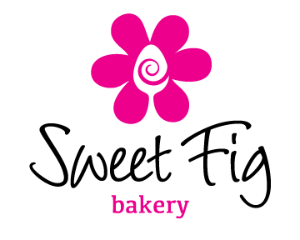 |  | Pastry Order Form  For Christmas Eve Pickup
Name: |  |  | Pickup Times For Platters
Phone: |  |  | 11:00 AM - 12:00PM | 12:00 PM –  1:00 PM |  | 1:00 PM –  2:00 PM
Email:
Order Details
Quantity | Product |  | Amount |  | Total Price
 | 10 Piece Assorted Platter |  | $25.00
 | 20 Piece Assorted Platter |  | $45.00
 | 30 Piece Assorted Platter |  | $65.00
 |  |  | Total Order Cost
 |  |  | Amount Paid
 |  |  | Amount Owing
Pastry platters will be an assortment of the following croissants: Double Baked Almond, Chocolate, Bacon & Cheddar, Traditional Butter and Fruit Danish. Platters will also include homemade lemon curd and mascarpone cream.
Orders must be submitted by Monday, December 22nd, 2014.

